Name:
Dawood Sarfraz

Roll no:
20p-0153

Section:
BSCS-9A

Assignment no 4:
Build Automation (Pre-Processors)

Submitted to:
Dr. Omar Usman Khan

1. What happens if you rename the file to my_header_file.txt and include this file only?
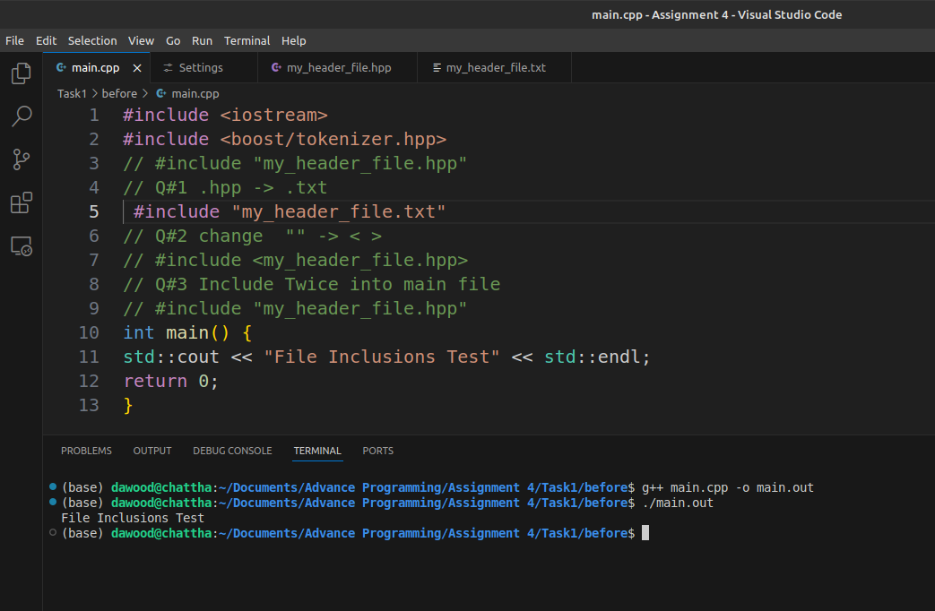

2. What happens if you change “” to < > just like iostream is enclosed in <>.

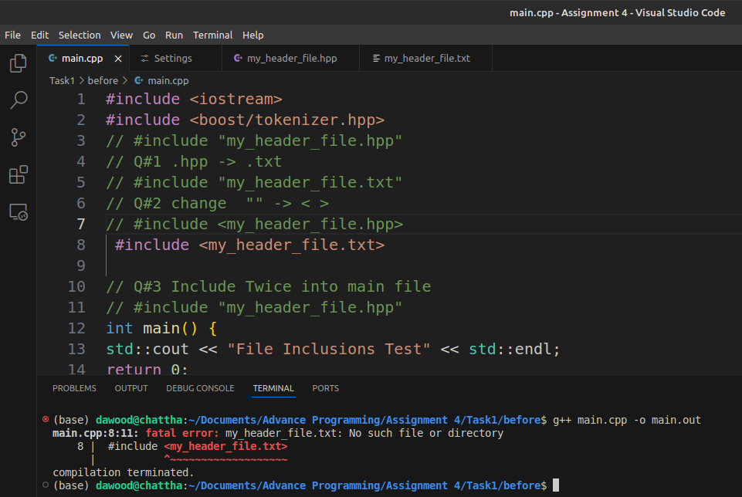
#Practice
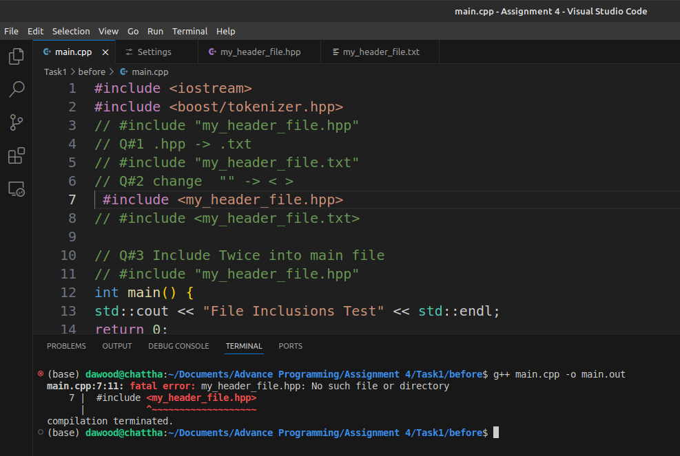

3. What happens if you do #include “my_header_file.hpp” twice in your code?

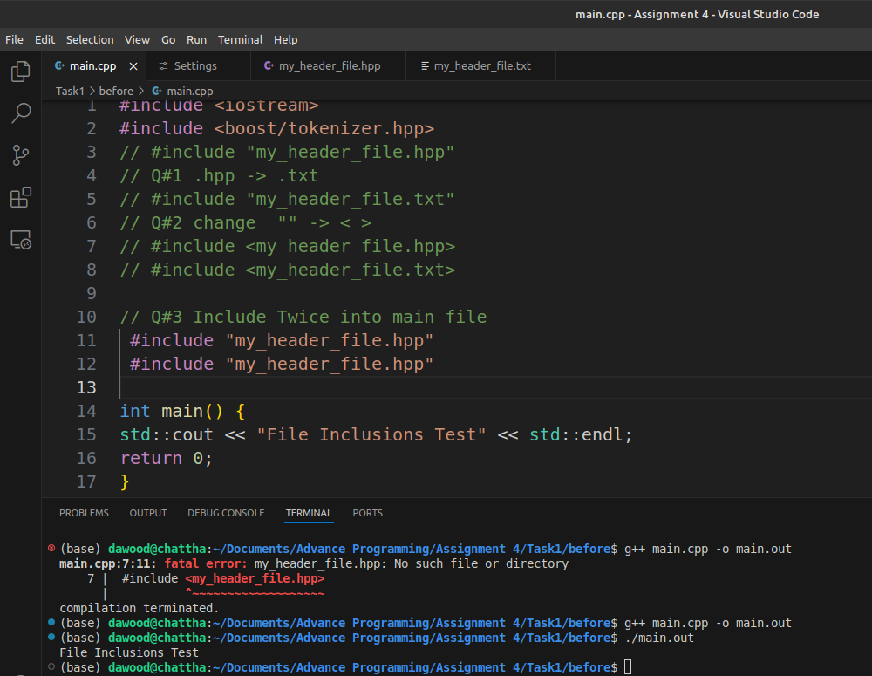

# Practice

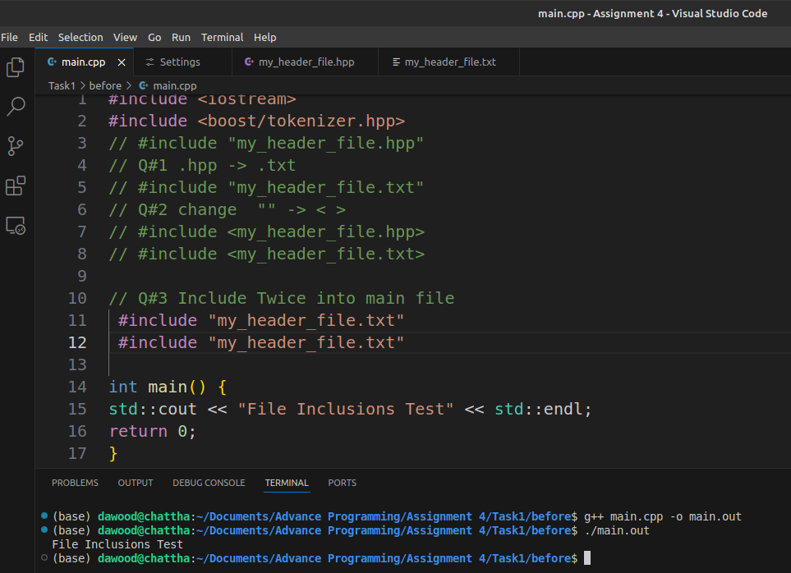
# Practice

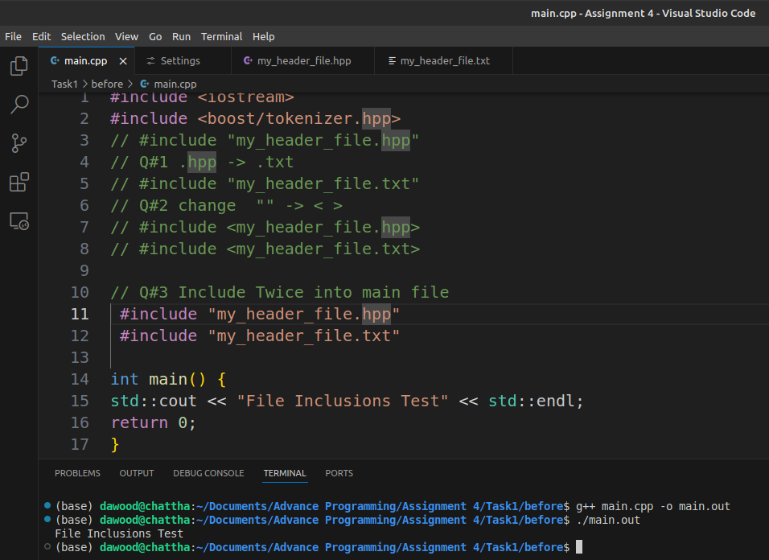

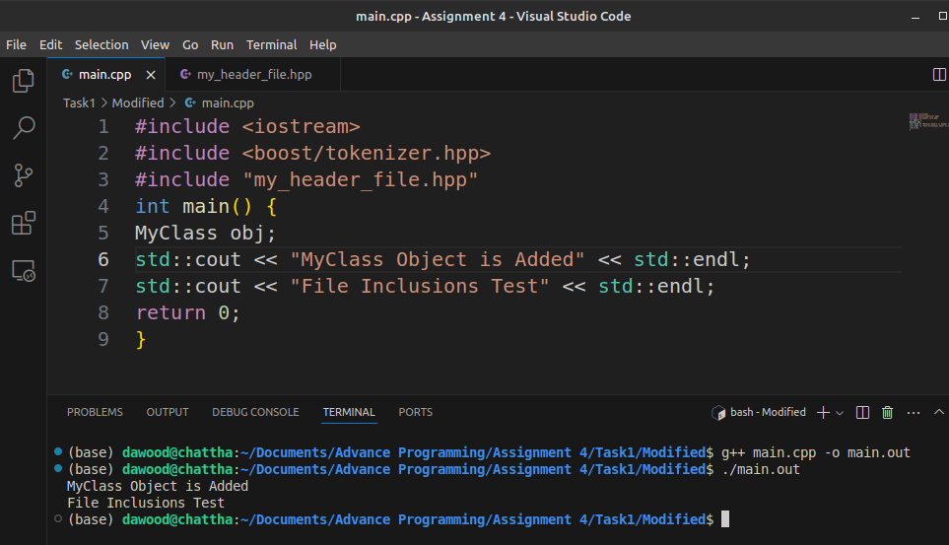

4. What happens if you do #include “my_header_file.hpp” twice in your code?

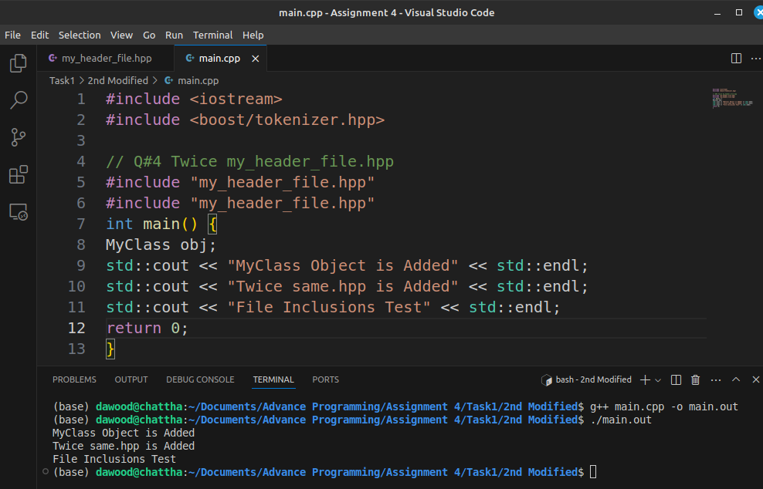

5. What happens if you do #include “my_header_file.hpp” twice in your code?

6. What happens if you rename #ifndef to #ifdef?
